**Post lab**

**4.1)**

A mod 12 counter will return back to the minimum state (0000) after reaching binary 12 (1100). Because of this we can add some external logic that will manually pulse the reset pins of all JK flip flops when (1100) is reached.

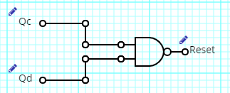

Assuming that outputs are labelled with A being the least significant, and D being the most significant, then by putting outputs C & D through a NAND gate would lead to a low whenever the binary 12 is reached. If there was connected to the reset pins of all the flip-flops, then this would create a mod 12 counter.

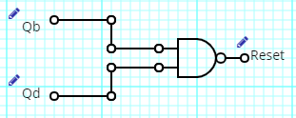

This same logic can be used to make a mod 10 counter, however the logic will now reset the count on a binary 10 (1010). To achieve this place outputs B and D through a NAND gate to pull a low on the reset pin when ever a binary 10 is reached, resetting the flip-flops.

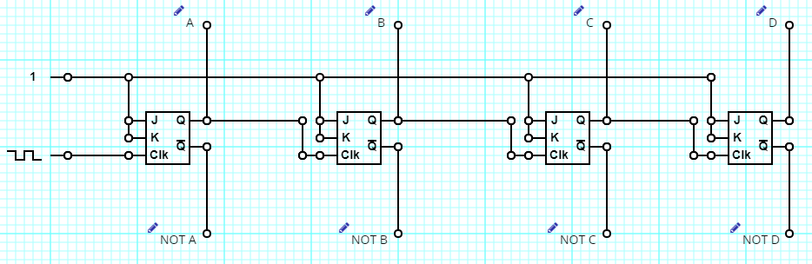**4.2)**

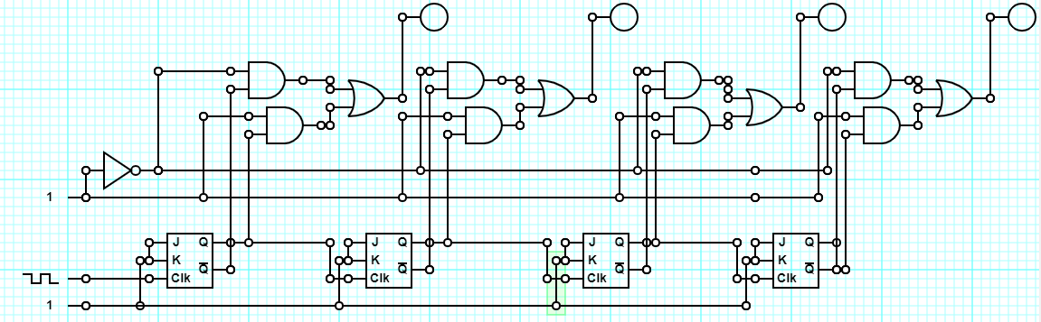In order to utilise this as a down counter, rather than reading the inputs of A, B, C, and D. You can read the inputs of NOT A, NOT B, NOT C, and NOT D. To be able to select which direction you are counting, you can AND output Q with a high, and then and input NOT Q with a low, and then OR the outputs.